Titan v7 Controls

Input Controls

CmsCheckableItems

Item type: Checkbox
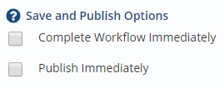

Item type: Radio
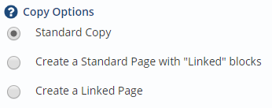

Item type: Radio (with custom display)
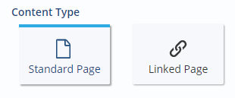

CmsCKEditor

CmsContentPicker

Image/File Picker
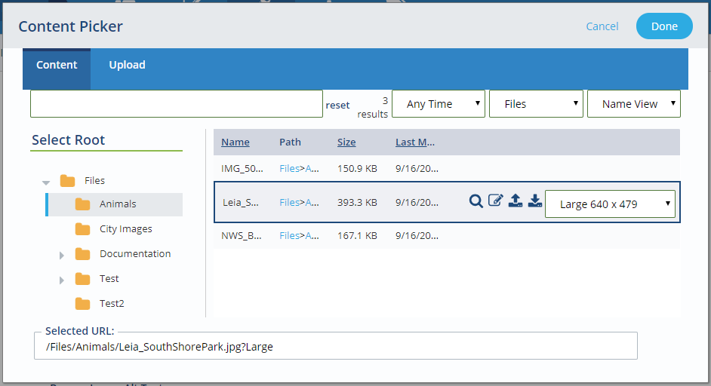

Folders Only
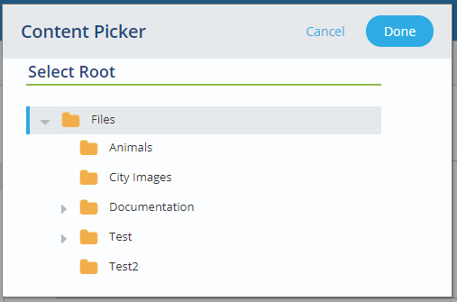

Linked Content
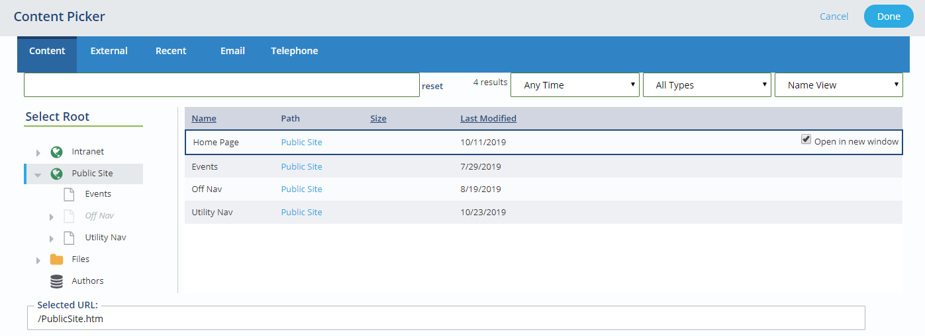

CmsCustomUrlChecker

CmsCustomUrlCollection
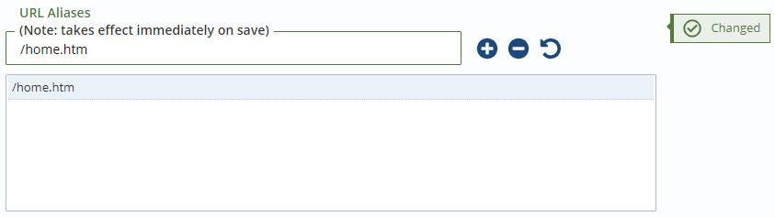

CmsDate
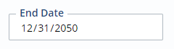

CmsDateTime
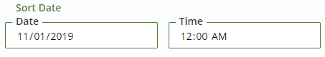

CmsDropdown

CmsFilePicker

CmsFileUpload

CmsGeographicPoint
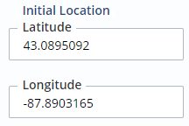

CmsHiddenInput
(Just renders a hidden input!)

CmsKeyValuePairs

Tag Attributes
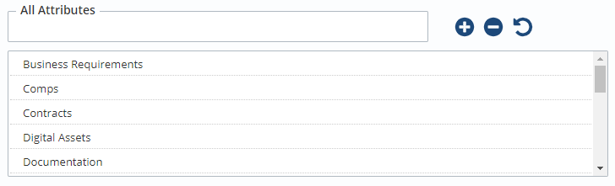

Range Attributes
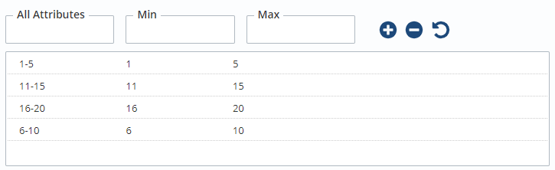

CmsLinkItemCollection
Not yet implemented.

CmsLinkBuilder
Not yet implemented.

CmsMultiFilePicker
Not yet implemented.

CmsNameValuePairs
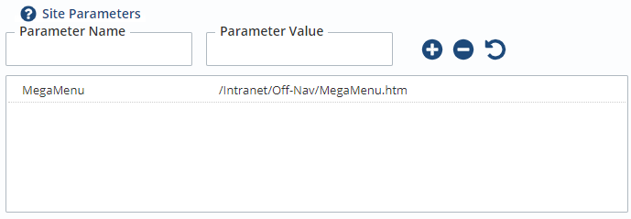

CmsNavPicker

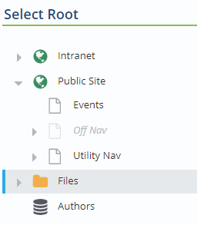

CmsRecurringDateTime
Not yet implemented.

CmsSuggestListBox
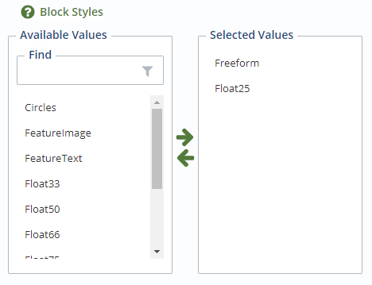

CmsTagsPicker
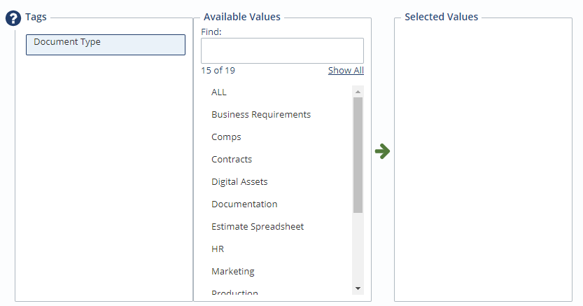

CmsTextInput

CmsTextAreaControl
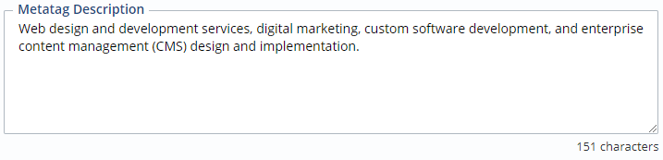

CmsViewDropdown
Not yet implemented.

CmsViewPicker
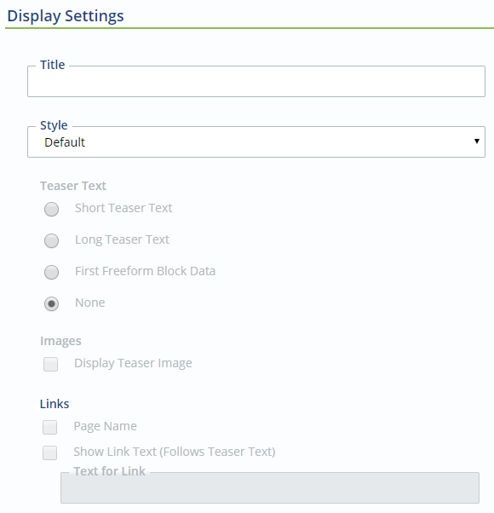

Label/Message Controls

CmsBubbleMessage
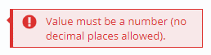

CmsHeader

CmsNotice<T>

ExtraCssClasses = “info”

ExtraCssClasses = “alert”
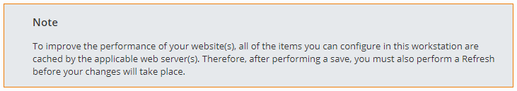

ExtraCssClasses = “error”

CmsSimpleHelp

Closed

Open
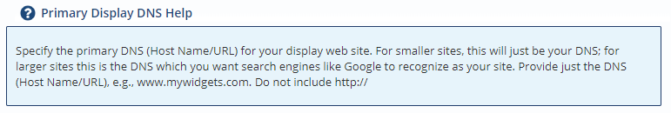

CmsSpan
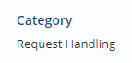

CmsStaticHtml
